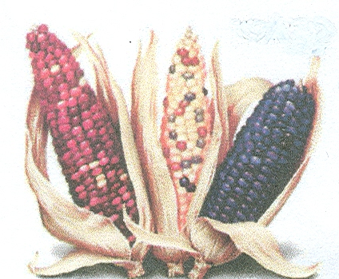
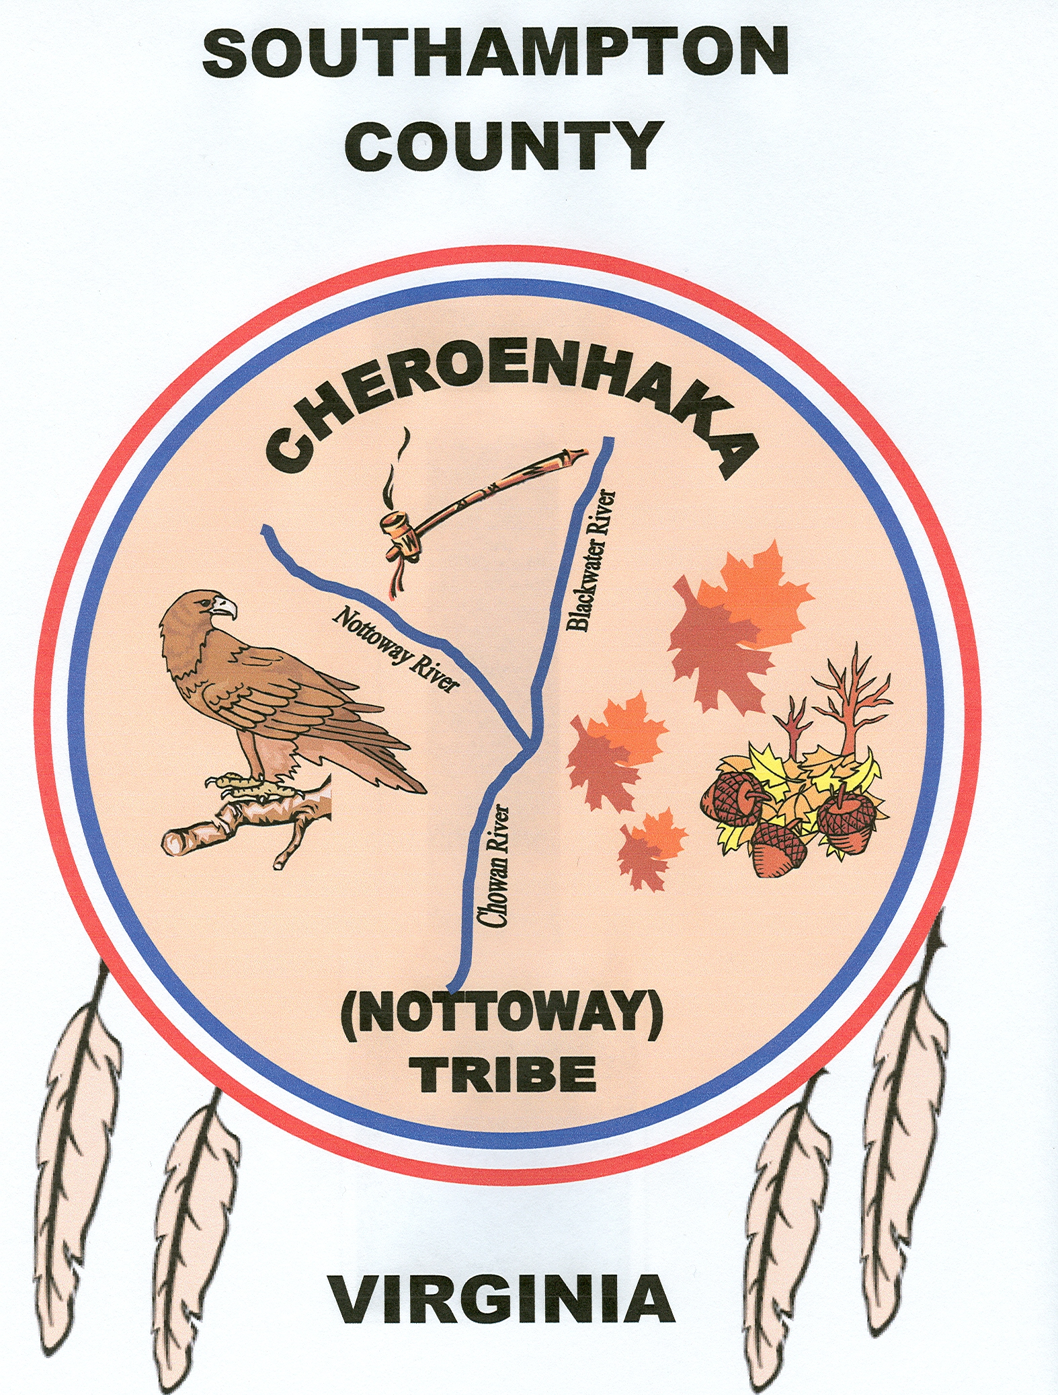
CHEROENHAKA (NOTTOWAY) INDIAN TRIBE
SOUTHAMPTON COUNTY, VIRGINIA

27345 Aquia Path / P.O. Box 397
Courtland, Virginia 23837

“PEOPLE AT THE FORK OF THE STREAM”

“Quaker-hunte, EE Sun-ke Was-we-kr (Creator, My Heart Speaks)

35th CHEROENHAKA ( NOTTOWAY) INDIAN “GREEN CORN” POWWOW & GATHERING ARTS & CRAFT VENDOR CONTRACT

(PLEASE PRINT ALL INFORMATION)

Name of Organization / Trader: ___________________________________________

Contact Person : ________________________________________________________

Address: ______________________________________________________________

City:__________________ State ______ Zip ___________ Phone: _____________

Tribal Affiliation _________________________ E-mail : ______________________

“Come See Our Native Palisade Village – Cattashowrock Town” _____________________________________________________________________
This contract shall be between the Cheroenhaka (Nottoway) Indian Tribe of Southampton County Virginia and person(s) or organizations named above, hereafter, to be known as Vendor. The Arts & Craft Vendor/ Exhibitor contract for said “GREEN CORN ” Annual Pow-Wow & Gathering will be subject of the following terms:
- The event will take place on Saturday, July 5, 2025.
- The Vendor/ exhibitor must be/have Native American wares.
- The highest conduct / integrity is expected of all exhibitors in their assigned areas, as well as on the Pow-Wow grounds in general. The consumption of alcohol and / or of illegal substances is prohibited. This policy will be enforced by Pow-Wow security personnel and police.
- The Cheroenhaka (Nottoway) Tribe nor the Cheroenhaka (Nottoway) Indian Heritage FD, will not be responsible for any lost, stolen or damage merchandise, nor shall they assume any responsibility for any PERSONAL INJURY incurred.
- The Cheroenhaka (Nottoway) Tribal Council reserves the right to make all final decisions germane to Pow-Wow functions.
- Electricity will be provided for the Drum Arbor ONLY! Campers will be parked in a designated area. Bring your Generators!
- Raffles from exhibitor’s / vendors will not be permitted.
- The Cheroenhaka (Nottoway) Indian Tribe reserves the right to determine the Authenticity and approval of all items entering the Pow-Wow Grounds.
- Each Vendor / Exhibitor is responsible for providing his / her liability insurance.
- Booths will be manned at all times during the operating hours of the Pow-Wow.
(See Back of Agreement)
I / We have read and understand the rules and terms of this contract / agreement and I / We agree to pay the ARTS & CRAFT Vendor Fee: 10’ X 10’, $85.00 and for a 10’ X 20’, $100.00 for a ONE DAY set-up at the 35th Cheroenhaka (Nottoway) Indian Inter-Tribal Green Corn Pow-Wow and Gathering, on the Tribe’s 263 acres of Tribal Land located at Cattashowrock Town, 27345 Aquia Path, off Rt. 742 South, Cheroenhaka Rd & Cattashowrock Trail, Courtland, VA 23837, on Saturday, July 5th, 2025 from 10:00 AM to Sunset. VENDOR FEES ARE DUE UPON ARRIVAL AND PRIOR TO SET-UP.

  - NOTE: July 4th, 2025 Vendors can setup after 2pm.

REPRESENTATIVE (Organization / Trader)

______________________________________ _______________________
(PRINT NAME) (BOOTH SIZE)

________________________________________ ______________________
(SIGNATURE) (DATE)

(A $50.00 Security Deposit is Enclosed ______ (yes) _______ (no))

CHEROENHAKA (Nottoway) Tribal Representative

Chief Walt “Red Hawk” Brown
Email: WDBrownIII@aol.com
Tel #: (757) 354-6839
______________________________________
(PRINT NAME)
July 5, 2025

______________________________________ ______________________
(SIGNATURE) (DATE)

Please Return This Form To: Cheroenhaka (Nottoway) Indian Tribe
ATTN: Powwow Chair(s): (Chase and Rickie)
P.O. Box 397 / 27345 Aquia Path
Courtland, Virginia 23837
Telephone # 757-869-1180 Cell (Chase)
Telephone # 252-506-1249 Cell (Rickie)
Telephone # 757-354-6839 Cell (Chief Brown)
E-mail: rcturner2727@gmail.com
E-mail: rickie_two_beavers@yahoo.com
E-mail: wdbrowniii@aol.com

Tribal Website: http://www.cheroenhaka-nottoway.org
For office use only
Date received:_________ Approved:_________ Disapproved:_______
Chairman of Powwow Committee:___________________________________ (signature)

