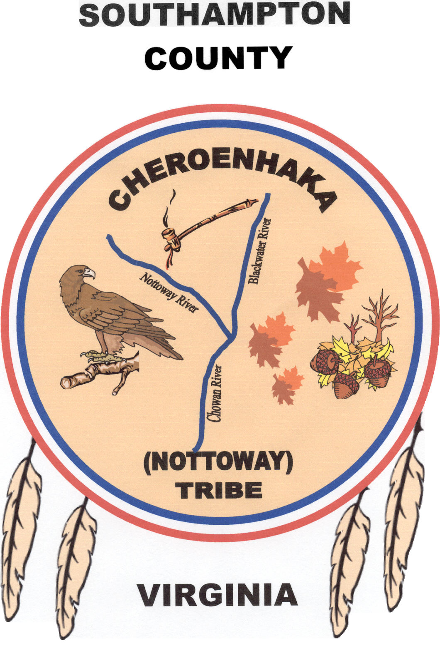
CHEROENHAKA (NOTTOWAY) INDIAN TRIBE SOUTHAMPTON COUNTY VIRGINIA
P.O. Box 397
Courtland, Virginia 23837

ANNUAL TRIBAL MEMBERSHIP RENEWAL
$60 Administrative Fee or $15 per quarter; College Enrolled students (Undergrad) $30 Per Annual; Over age 62, $50 per annual or $12.50 per Quarter; 80+ no fees

___ Check to indicate a new address Joining Year ____________

Name __________________________________________________________________

Address ________________________________________________________________

City ___________________________ State _______________ Zip Code ___________

Email __________________________________________________________________

Telephone #: Home_________________ Work_______________ Cell _____________

Names of Children (under age 18)
___________________________________________________________ Age ________
___________________________________________________________ Age ________
___________________________________________________________ Age ________
(if needed, write additional names of children on the back of this form)

Please mail this form with your administrative fee(s) to the following address: (Pease make checks payable to the “Cheroenhaka (Nottoway) Indian Tribe)

Cheroenhaka (Nottoway) Indian Tribe
ATTN: Ellis “Soaring Eagle” Wright, Treasurer
P.O. Box 397
Courtland, Virginia 23837

Thank you for your Tribal Support

(FOR OFFICE USE ONLY)

1st Quarter____ 2nd Quarter____ 3rd Quarter_____ 4th Quarter_____ Tribal Card____

